**Maybe~~**

Build an online quiz application:

* Use React Router to create routes for the home page, news page, about page, contact page and quiz page.

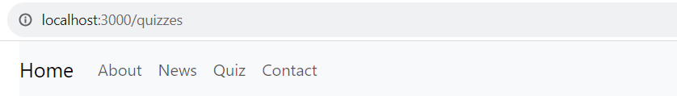

* Display slide on the home page.

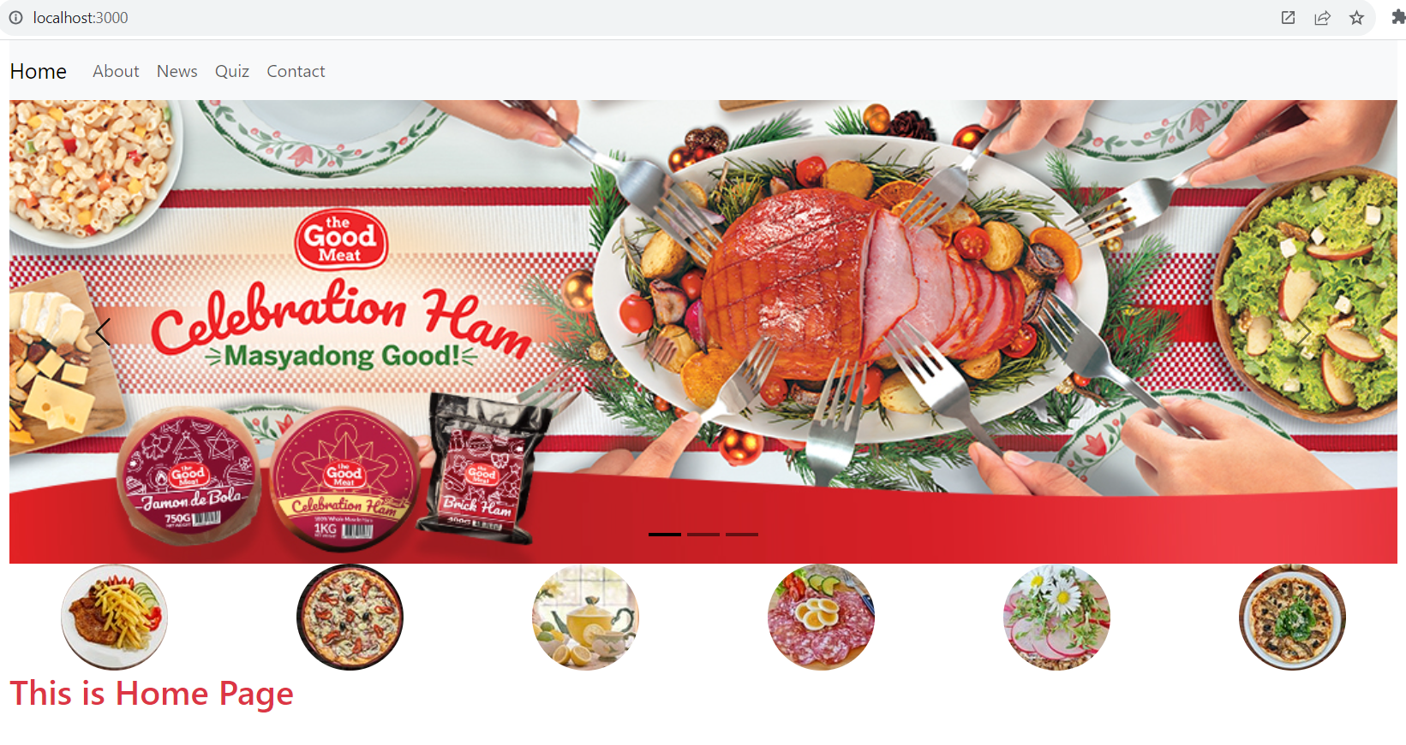

* Display the list of news on the News page.

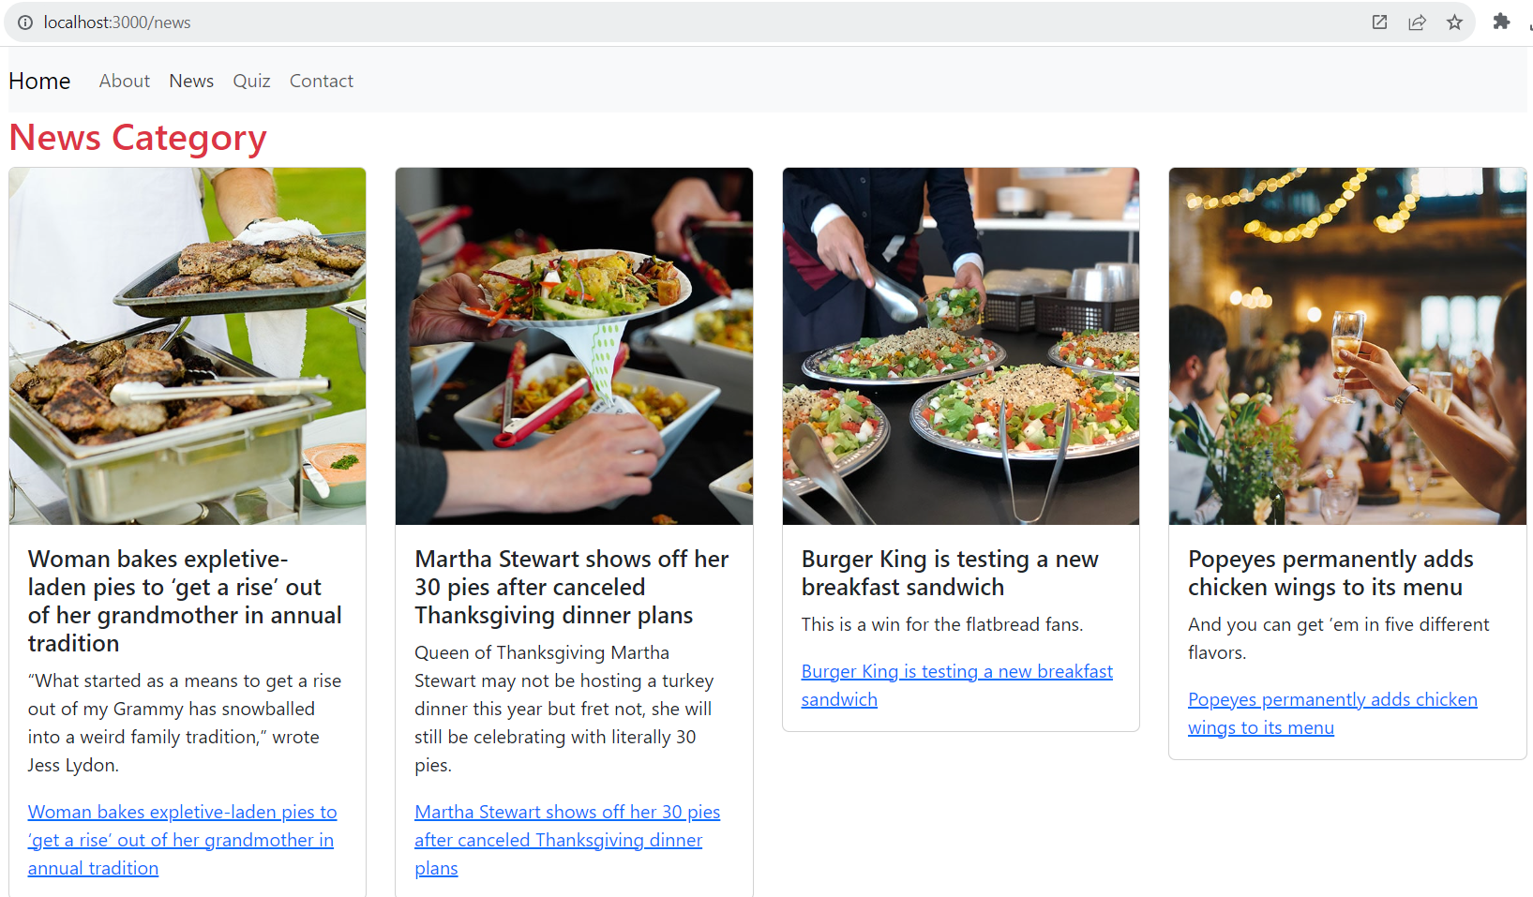

Note: Use an array to store information about News

    const newLists = [

        { id: 1, title: 'Woman bakes expletive-laden pies to ‘get a rise’ out of her grandmother in annual tradition', description: '“What started as a means to get a rise out of my Grammy has snowballed into a weird family tradition,” wrote Jess Lydon.', images: 'images/event-1.jpg' },

        { id: 2, title: 'Martha Stewart shows off her 30 pies after canceled Thanksgiving dinner plans', description: 'Queen of Thanksgiving Martha Stewart may not be hosting a turkey dinner this year but fret not, she will still be celebrating with literally 30 pies.', images: 'images/event-2.jpg' },

        { id: 3, title: 'Burger King is testing a new breakfast sandwich', description: 'This is a win for the flatbread fans.', images: 'images/event-3.jpg' },

        { id: 4, title: 'Popeyes permanently adds chicken wings to its menu', description: 'And you can get ’em in five different flavors.', images: 'images/event-4.jpg' },

        { id: 5, title: 'Top salmon with a sizzling mix of aromatics and spices', description: 'Tadka is a ubiquitous South Asian technique that adds a dramatic last-minute coat of flavor.', images: 'images/event-5.jpg' },

        { id: 6, title: '80 Christmas dinner ideas for the ultimate holiday feast', description: 'Build the perfect Christmas menu with these delicious recipes.', images: 'images/event-6.jpg' },

        { id: 7, title: 'How to make the easiest prime rib roast for the holidays', description: 'Use these tips and tricks to make a juicy and amazingly delicious prime rib roast.', images: 'images/event-7.jpg' },

        { id: 8, title: 'Turn leftover turkey into a flavorful Waldorf salad', description: 'This light, bright turkey salad is the best post-Thanksgiving lunch.', images: 'images/event-8.jpg' },

    ];

* Quiz page: Display the questions and options for the user to answer. You can use an array to store information about the questions and options, and use a separate component to display each question(as Lab 4).
* Contact page: Display the contact Form with react-bootstrap component

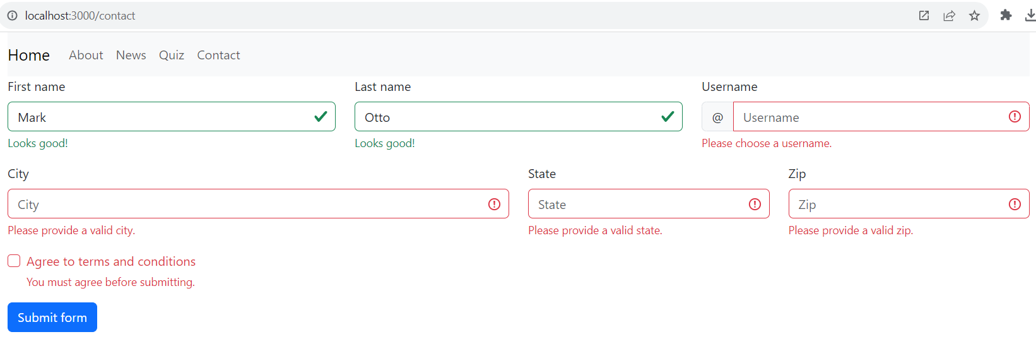

* Define routes: In the root component (App), define the routes using BrowserRouter and Link from React Router.
* In the Home and QuizList components, use Link from React Router to create links to the respective pages.

More Reference: <https://react-bootstrap.netlify.app/docs/getting-started/introduction>

Images Resource: [images.zip](https://feedu-my.sharepoint.com/:u:/g/personal/thuytt5_fe_edu_vn/EV0SwV17xrRIr9Cq4msZ-NABiriTip2qiwJUEFRXcwr5Fw?e=HL6y3c)